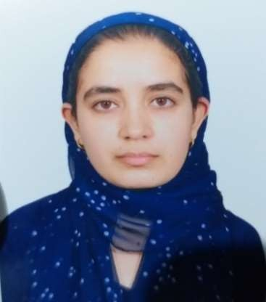

**AASIMA RASHID**

**9682540768**

[**aasimarashid90@gmail.com**](mailto:aasimarashid90@gmail.com)

# RESUME/CV

# Experience

1. Worked in Florence Paramedical and Nursing Institute, Anantnag as a nursing tutor for 1 year w.e.f 2nd July 2018 to 2nd July 2019.
2. Worked in Bibi Halima College of Nursing and Medical Technology, Rainawari, Srinagar as a tutor w.e.f. 1st april 2022 to 27th February 2023.
3. Worked in Alamdar Memorial College of Nursing and Medical Technology, Charar-i-Shareef, IUST as a tutor w.e.f. 27th February 2023 to 31st dec 2023.

1. Worked in SEM College of Nursing and Paramedical Sciences, Humhama, Budgam as a tutor w.e.f. 1st January 2024 to 19th june 2024
2. Worked in Institute of Nursing, South Campus, University of Kashmir, Anantnag as a tutor w.e.f. 20th june 2024 to 31st December 2024

# Education

|  |  |
| --- | --- |
| **MSC Nursing in Medical Surgical Nursing (2019-2021)**  ***Super Specialty:*** *Critical Care Nursing*  Jamia Hamdard, New Delhi, | 1082/1500  **(72.13%)** |
| **BSC Nursing (2014-2018)**  SKIMS Soura, Srinagar. | 1918/2800  **(68.5%)** |
| **10+2 (2012) JKBOSE**  Walden Higher Secondary School  Srinagar, Kashmir. | 404/500  **(80.8%)** |
| **Matriculation (2010) JKBOSE**  Walden Higher Secondary School  Srinagar, Kashmir. | 444/500  **(88.8%)** |

**Registration details**

Registered in the Nurses and Midwives register maintained under the provisions of the J& K State Paramedical & Nursing Council Act, 2012 as a Registered Nurse and Registered midwife.

Registration Number Assigned : **7714**

**Research Work**

1. “A study to assess the effectiveness of Structured Teaching Programme regarding the prevention of Urinary Tract Infection with indwelling catheter among BSc Nursing 2nd Year students of Madr-e-Meherban Institute of Nursing Sciences and Research SKIMS Soura” for the award of the degree of B.Sc. Nursing from Deemed university Sher -e- Kashmir Institute of Medical Sciences, Soura, Srinagar, Kashmir, 2016.
2. “A descriptive study to assess the knowledge regarding preventive measures and to identify coping strategies related to COVID-19 among adult population in a selected area of Kashmir” for the award of degree of Masters of Sciences in Nursing from Jamia Hamdard (Deemed to be university), New Delhi, 2020.
3. “A cross sectional study to assess the post operative pain and analgesic use among the patients undergoing surgery in orthopedic ward of selected hospitals of Srinagar Kashmir” as a Co- Guide in Alamdar College of Nursing and Medical Technology, Charar-i-Shareef, IUST,2023.

**Research Publications**

“A descriptive study to assess the knowledge regarding preventive measures and to identify coping strategies related to COVID-19 among adult population in a selected area of Kashmir” 2021, Volume 8, Issue 2&3, Pg. No. 24-29 under International Journal of Nursing and Midwifery Research, Advanced Research Publications.

# Personal details

Name : Aasima Rashid

D/o : Abdul Rashid Zargar

DOB : 15-08-1994

Residence : Stadium Colony Budshahnagar Natipora Srinagar- 190015 Lane No. 4, House No. 3.

Contact No. : 9682540768

Email : [aasimarashid90@gmail.com](mailto:aasimarashid90@gmail.com)